NEWTON’S SECOND LAW OF MOTION

What does this mean?

What variables govern the acceleration of the following bodies?


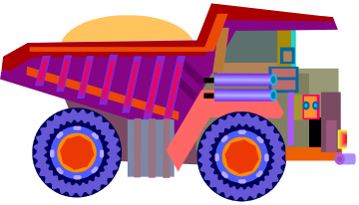

NEWTON’S SECOND LAW can be stated as:

a = _F_
m

where a = acceleration in msֿ²
F = total force on the object (Newtons)
m= mass of the object (kg)

Can also be stated as F = m a

Example: A space shuttle has a mass of 2.2 million kilograms, of which 86% is the mass of fuel, most of which is burnt during the launch. There are two forces acting on the space shuttle; downward pull of gravity, at 22 million Newtons, and the upward thrust resulting from the burning of fuel which is about 29 million Newtons. The forces acting on the space shuttle are not balanced. The total force acting on the space shuttle is 7 million Newtons upwards.

Newton’s second law of motion can be used to estimate the acceleration of the space shuttle at blast off:

a = _F_
m

= 7 000 000 N upwards
2 200 000 kg

= 3.2 msֿ²

The space shuttle is gaining speed at the rate of only 3.2 msֿ² or 11.5 km/h each second. Small acceleration at blast off is not a problem because as the fuel is burnt, the mass of the space shuttle gets smaller. As this happens the acceleration gradually increases, and the space shuttle gains more speed quickly.

Practice Exercises

- What force will accelerate an 18 kg object at 3 msֿ²?

- Find the mass of a block if a 65 Newton force accelerates it at 2.5 msֿ².

- An 8000 N force acts on a 125 kg vehicle. What acceleration is produced?

- A 150 kg motorcycle is retarded at 2.5 msֿ². Find the force that is required.

- What acceleration would be given to a 950 kg car by a 222.6 N retarding force.

- A 10 kg sled is pulled across the snow so that the total force acting on it is 12 N. What is the size of the average acceleration of the sled?

- What total force would cause a 1.5 kg glass salad bowl to accelerate across a table at 0.30 msֿ²?

- Two identical toy carts, A and B, each with a mass of 1.0 kg, are pushed across a smooth, level table top with same force. One of them contains a heavy brick. Cart A accelerates more rapidly than Cart B.

  - Which toy cart contains the brick? How do you know?
  - If the acceleration of the cart A is 2.0 msֿ², what is the total force acting on each cart?
  - If the acceleration of cart B is 0.5 msֿ², what is the mass of the brick?

